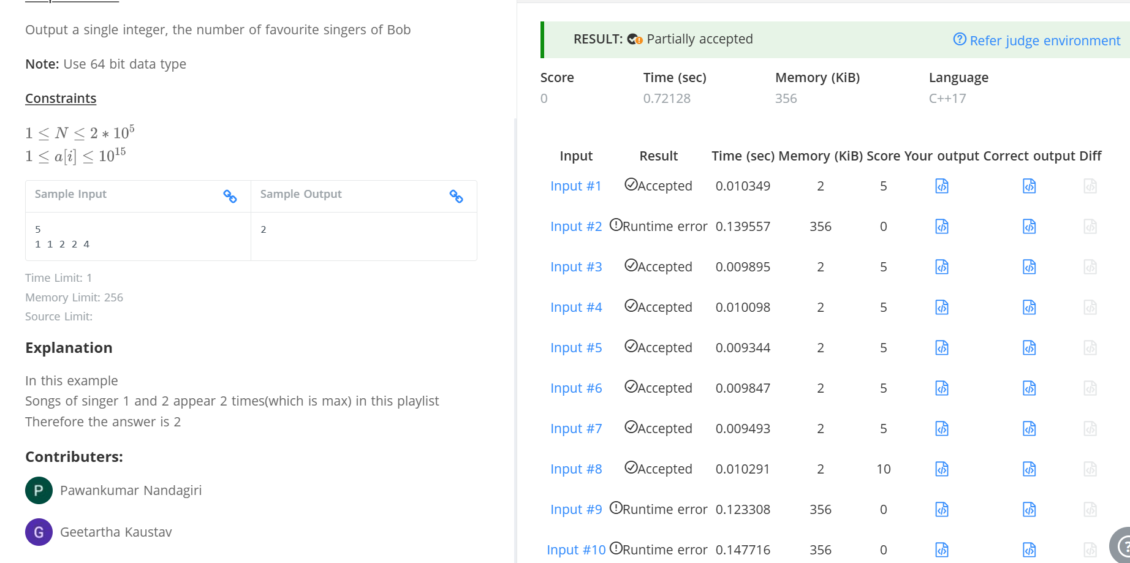\

Q Favorite Singer
#include <iostream>
using namespace std;

int main() {
int N;
cin >> N;
int freq[1000]={0};
int sno;
for(int i=0;i<N;i++){
cin>>sno;
freq[sno]++;
}
int max=freq[0];
for(int i=0;i<=1000;i++){
if(freq[i]>max){
max=freq[i];
}
}
int count =0;
for(int i =0;i<=1000;i++){
if(freq[i]==max){
count++;
}
}
cout<<count;
return 0;
}

